Laboratory 4

- Antonio Suciu, 937/1 –

[Github link](https://github.com/AntonioSuciu/FLCD/tree/main/Labs/Lab%204)

Write a program that:

1. Reads the elements of a FA (from file).

2. Displays its elements, using a menu: the set of states, the alphabet, all the transitions, the initial state and the set of final states.

3. For a DFA, verifies if a sequence is accepted by the FA.

**Deliverables:**

1. FA.in - input file (*on Github*)
2. Source code (*on Github*)
3. Documentation. It should also include in BNF or EBNF format the form in which the FA.in file should be written (*on Moodle and Github*)

***Max grade = 9***

***Max grade = 10:*** Use FA to detect tokens <identifier> and <integer constant> in the scanner program

Finite Automaton Class

* Alphabet
* States
* initialState
* finalStates

^ sets of strings

* transitions ( map, keys: Pair(Source state, value to access the destination state), values: set of Destination states)
* DFA ⬄ Destination states set has size 1 (there can be only 1 destination)

Check that FA = DFA: We use the above stated condition

Check that a sequence is accepted by the DFA:

* We start from the initial state
* We iterate through the characters of the sequence
* We check that the pair (currentState, valueOfCurrentChar) is mapped to a set with a single value
* If it is, we have our new current state in for the given iteration
* If we find no mapping => it means it is not accepted

Finite Automata

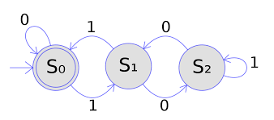

letter ::= a | b | ... z | A ... Z

digit ::= 0 | 1 | ... 9 |

alphabet_char ::= letter | digit

alphabet ::= {alphabet_char}+

state ::= letter

states ::= {state}+

initial_state ::= state

final_state ::= {state}+

transition::= state alphabet state

